Summer 2021

Grants News

LI Traditions has been recognized for several new projects and other ongoing projects. The National Endowment for the Arts awarded LI Traditions a multi-year grant from the Folk and Traditional Arts program to support our maritime folk arts education programs in Freeport and East Williston school districts, and a joint program with the New Bedford Fishing Heritage Center, one of our folk arts partners. Stay tuned for details. We’ve also received another year of funding for our new cell phone tours around New York State, as a result of a generous grant from the NY State Council on the Arts. We have also received grants as part of the payroll protection plan.

Graduate School Intern Georgia “Ellie” Dassler

We welcome Georgia “Ellie” Dassler, a recent graduate of Western Kentucky University’s graduate studies folklore program to Long Island Traditions. Dassler received the WKU Graduate School award and was also been the Outstanding Folk Studies Graduate Student. Ellie has also served as the editorial assistant for the Journal of American Folklore (JAF). Ellie will be working on a new cell phone tour that explores Long Island’s ethnic traditional culture in Nassau and Suffolk Counties. We welcome Ellie and look forward to working with her. The internship is funded by the Gardiner Foundation and the NY State Council on the Arts/NY Folklore.

Bay House Tours 2021
August 28 and September 12
On Saturday, August 28 and Sunday, September 12 Long Island Traditions will sponsor its annual Bay House Tours in the Town of Hempstead. Departure times are 11 a.m. and 1 p.m. Don’t miss this opportunity to visit the last reminders of Long Island’s nautical past that are still used today by the area’s baymen. Many bay houses were destroyed by Superstorm Sandy but many have been rebuilt.
Participants must be fully vaccinated and be able to climb ladders and feel comfortable in a work environment. The August 28 tour will leave from Freeport, and the September 12 tour will depart from Long Beach. Due to safety concerns, space is limited to 12 people per trip, ages 10 and up. Long Island Traditions members can register beginning June 14. To join Long Island Traditions, visit our web site. All others can register starting July 7. The ticket limit is 2/per person. For reservations, call LI Traditions at (516) 767-8803 to confirm availability. No children under 10 permitted. Rain and construction problems may cancel the event.
Tickets for the Bay House Tours are $55 for adults, $100/couple, with a $5 discount for LI Traditions members.
The tour will be led by LI Traditions Director Nancy Solomon. Those on board will be treated to a brief history of the bay houses, the first of which were built in the 1700s. Bay houses were traditionally used by fishermen who harvested clams, oysters, crabs, and other species from local waters. The surviving houses date from the period between 1870 and 1950. Each tour will visit two bay houses.
Chris Hale: Boat Builder and Model Maker

Editor’s Note: Chris Hale will be featured in the upcoming book about boat builders and boatyards, written by Nancy Solomon. The book is in production and will be published by History Press in 2022. Chris has been a participant in our school and public programs. Stay tuned for upcoming maritime folk arts programs.

Chris Hale is one of the most accomplished boat half-model makers, who has devoted himself to recreating replicas of historic south shore wooden boats, including garveys, skiffs and cat boats. He has worked at many boat yards on Long Island, including Coecles Harbor Marina on Shelter Island, at Hampton Shipyard in East Quogue, and currently at Weeks Boatyard in Patchogue where he has worked since the 1990s. He works on restoring traditional wooden boats ranging from skiffs and cat boats to modern recreational fishing boats. At Weeks Boat Yard, Hale is responsible for building fiberglass racing and pleasure boats. Hale is one of the few boat builders who also make “half models” of traditional boats that once graced Great South Bay. He follows a long line of traditional boat builders who make half models, a tradition that was carried on by Fred Scopinich of Freeport, Paul Ketcham, and other traditional boat builders.

Hale was born in Glen Cove Hospital and grew up in Massapequa. As Chris recalled “My great grandfather was a boat builder and he had these three half models kicking around the beach house which I liked. We also used to go down to Sag Harbor a lot and look at the boats on the dock. Eventually we got a rowboat. But I always liked boats as a kid. I didn’t know that you could get a job working on them. I thought they came from a magical place or something. I never gave it much thought until high school.”

When Hale graduated from high school, he pursued a career in boat building, (an unusual choice in the late 1970s), by looking for a traditional boat building school. “I learned a lot at the trade school. I went to the Landing Boat Shop which is in Arundel, Maine.”

Upon graduation Hale worked at various boat yards on Long Island, including Sea Fair Yachts in Huntington, where he quickly rose through the ranks and became head of their wood shop, working on complex projects. When they closed in 1984, Hale attended Southampton College, earning a history degree. He also worked at the Hampton Shipyard run by the Scopinich family until 1990.

For several years Hale worked independently on a variety of projects, while also helping Anders Langendal and Al Grover. He travelled to North Carolina where he worked at Gary Davis Boat Building, eventually returning to Long Island and working at Coecles Marine Harbor on some of Billy Joel’s boats. In 1995 he met Brian Weeks and began working at the Weeks Boat Yard, where he remains today.

Hale began making models when he was attending the Landing School, a common requirement at boat building academies. He makes several varieties of half models, including both recreational and commercial boats. Using specialized tools, and varied wood types, Hale makes garveys, models of sailing racing boats, and other boats commonly found on Great South Bay.

In addition to boat building and model making, Hale spent many years racing in competitive tournaments, including those sponsored by the Bellport Yacht Club. In early years he used to race every weekend, and would travel to other club’s regattas. These days, he prefers working on models. “My favorite thing to do is to work on the models. Making models of all America’s cup boats. I want to build another boat, and I love restoring them. But my passion is making models.”
Bay House Book and Film

Want to learn more about Long Island’s legendary bay houses? We can help. We have two offerings in our online shop that you won’t want to miss.

- “On the Bay” is the book authored by our Executive Director, Nancy Solomon. Now in its second edition, the book documents the traditional lifestyle of present-day bay house dwellers whose families have harvested these waters for more than three centuries, through historic and contemporary photographs, architectural drawings and first-person narratives.
- “A World Within a World: Bay Houses of Long Island” is a documentary chronicling the history and traditions of Long Island’s South Shore bay houses in the Town of Hempstead. The film profiles Long Island families who have owned bay houses for over 100 years including the Muller, McNeece, Burchianti, Warasila, and Jankoski families. Local filmmakers Barbara Weber and Greg Blank capture the essence of how bay house owners have persevered and endured through severe storms and hurricanes, as well as eroding marshlands, while preserving traditions that began in the early 19th century.

The book and film cost $20 each, with a $5 discount for Long Island Traditions’ members. Visit our webpage (https://longislandtraditions.org) to order or to become a member.

LI Traditions archives

Did you know that our recorded interviews are available to the general public? If you would like to listen to one of our recordings they are available at the Long Island Studies Institute at Hofstra University in the Axnin library. You can reach them at (516) 463-6411. There are over 500 recorded interviews in the collection on the following topics: African Americans, Bay Houses, Ethnic Traditions, Great Neck, Jewish, Jones Beach, Latino, Maritime Culture, Occupational Culture, the South Shore Estuary, Storms and Hurricanes, Boats and Boatbuilders and West Meadow Beach. For more information visit https://www.hofstra.edu/special-collections/long-island-traditions.html

In addition, LI Traditions participates in the Voices from the Fisheries program sponsored by NOAA. Interview are available online at https://voices.nmfs.noaa.gov/ . Our collections include Long Island Traditions, Long Island Traditions – Climate Change and Sandy, and Peconic Estuary Interviews. We encourage you to explore our archives, and also our website where you can watch short curated videos, audio pieces, and other multi-media productions. And don’t forget to visit our YouTube channel!

Events of Interest
August 28 and September 12: Bay House Tours. See accompanying article. LI Traditions members’ registration begins June 14. General registration begins July 7. Call (516) 767-8803 for reservations.

Photos and captions
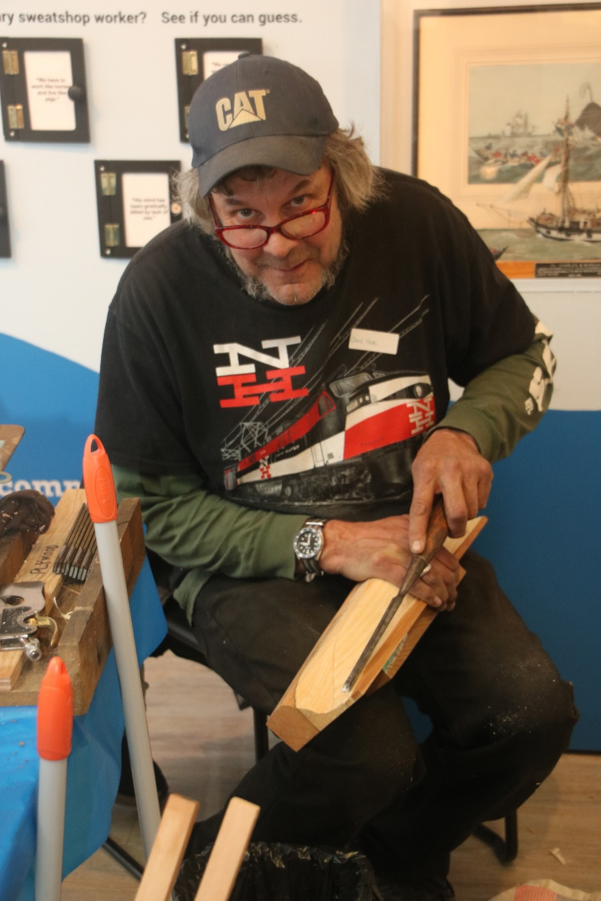
Chris Hale demonstrates model making at school and public programs. Photo by Nancy Solomon 2019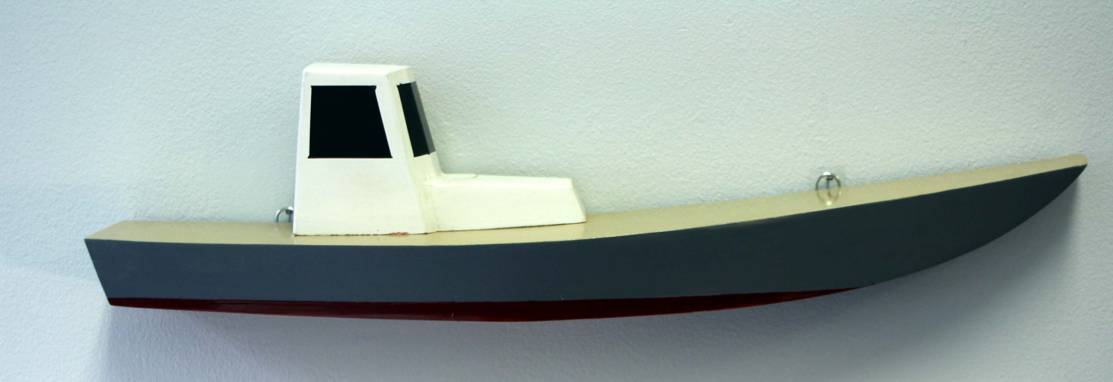

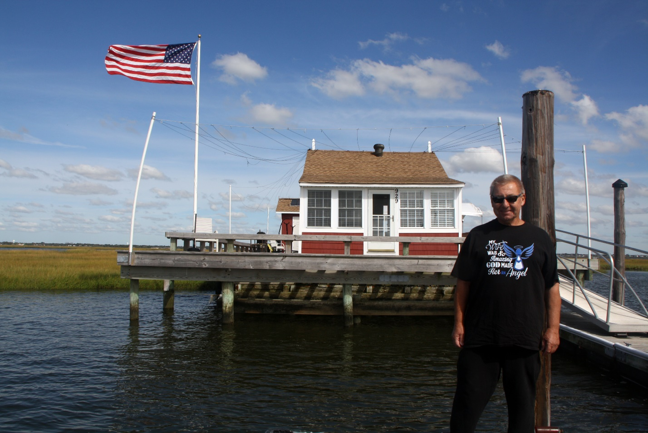
The Pidherney bay house will be one of our hosts on the 2021 bay house tour. Photo by Nancy Solomon 2015.

